Title
Voice-Based Authentication

Abstract:
This project implements a Voice based authentication system using a Machine learning Model for Biometric which takes Voice as Input from user. The system captures audio input through a browser, extracts relevant voice features (MFCCs), and uses a trained model to predict the speaker's identity. This method of authentication is contactless, efficient, and provides an innovative alternative to traditional password or biometric systems.

Introduction:
Voice-based authentication is a biometric technique that uses vocal characteristics to verify a person’s identity. Unlike traditional password systems, this approach leverages a user’s unique voice patterns, making it more secure and user-friendly. With advancements in machine learning and web technologies, it is now feasible to create lightweight, real-time voice recognition systems that run in the browser and verify identity instantly via a backend model.

Goals of the project Achieved
✅
❌
✅
✅
❌

Enable secure user authentication using voice input.
Record and train on voice samples of multiple users.
Accurately identify speakers in real time using FastAPI backend.
Provide an intuitive, responsive frontend with waveform visualization.
Minimize false positives using confidence thresholds
Software Requirements:
- Operating System:  / Linux / macOS
- (Python 3.10+)
- Web Browser (Chrome, Firefox, Edge)
Libraries Needed:
- Python Libraries: FastAPI, Uvicorn, pydub, librosa, scikit-learn, joblib, numpy, soundfile
- Node.js (optional for extended frontend build tools)
- Visual studio code
Hardware Requirements:
- Microphone (built-in or external)
- Minimum 4GB RAM
- Dual-core processor or higher
Frontend Details:
- Technology: HTML5, JavaScript , CSS3
- Features:
  - Start and Stop voice recording buttons
  - Real-time waveform visualization using <canvas>
  - Displays user prediction after voice input is sent to backend
  - Stylish gradient background and responsive design
Frontend Workflow (index.html)
- User Interaction
  - User visits the web page with modern browser
  - Sees a clean interface with "Start Recording" button
- Recording Process
  - Click "Start Recording" → browser requests microphone access
  - Audio visualization appears on canvas in real-time
  - User speaks their authentication phrase
- Stop & Send
  - Click "Stop & Send" to end recording
  - Audio chunks are combined into a WebM blob
- API Communication
  - Audio sent to backend at http://127.0.0.1:5000/predict
  - Displays "Analyzing..." status
  - Shows prediction result or error message

Backend Details:
- Framework: FastAPI (Python)
- Key Modules:
  - Audio conversion using pydub
  - Feature extraction using librosa
  - CORS middleware for cross-origin requests
  - Model training and prediction using KNeighborsClassifier from scikit-learn
  - File handling and cleanup with os, uuid

Backend Workflow (server.py)
- Request Handling
  - FastAPI receives POST request at /predict endpoint
  - Accepts WebM audio file upload
- Audio Processing
  - Saves temporary WebM file
  - Converts to WAV format using pydub
  - Extracts MFCC features using librosa
- Prediction
  - Loads pre-trained KNN model
  - Runs prediction on extracted features
  - Returns predicted user identity
- Cleanup
  - Deletes temporary audio files
  - Returns JSON response to frontend

Integration & API:
- API Endpoint: POST /predict
  - Accepts audio file (.webm), converts to .wav
  - Extracts MFCC features and predicts using the ML model
  - Returns JSON response with predicted user and confidence score
- Frontend communicates with backend using fetch() with FormData
- Real-time status updates shown in UI
Database:
- No persistent database is used in this version.
- Voice data is temporarily stored and processed.
- For extended systems, MongoDB or SQLite could be used to log results or register users.

Error Handling:
Error Scenario | Resolution
Microphone access denied | Check browser permissions
"Failed to fetch" | Verify backend is running
Prediction errors | Check audio quality/sample rate
Model loading failures | Retrain the model

Strengths of the Project:
- Fully functional across all modern browsers
- No additional hardware needed beyond a microphone
- Real-time, contactless, and secure
- Modular and expandable architecture (can add DB, OAuth, etc.)
- Visual feedback improves UX with waveform during recording
- Suitable for small-scale secure access systems, attendance tracking, etc.

Output screenshot:
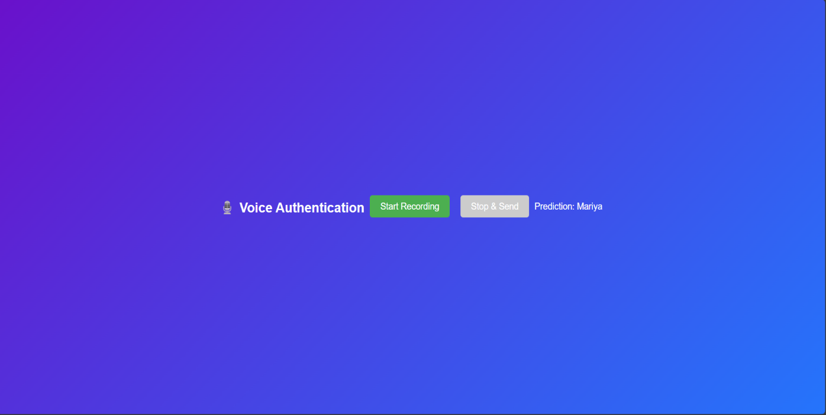
Optional Future Enhancements
- User registration via DB
- OTP or multi-factor with voice
- Replay audio on UI
- Admin panel to manage user recordings

10. References:
- Gitup repository: https://github.com/nathang15/Voice-Recognition-Authentication-System/tree/947ef0d645edefc905c4520ef4dde1e2985d66daVA
- FastAPI documentation: https://fastapi.tiangolo.com/
- Librosa documentation: https://librosa.org/doc/latest/index.html
- Scikit-learn documentation: https://scikit-learn.org/
- Pydub: https://github.com/jiaaro/pydub
- Mozilla Web API: MediaRecorder: https://developer.mozilla.org/en-US/docs/Web/API/MediaRecorder
- Uvicorn server: https://www.uvicorn.org/

